Online Shopping System: FootFusiom

Use-Case-Realization Specification: Manage Shopping Cart

Version <1.0>

Revision History

Date | Version | Description | Author
28/11/2024 | 1.0 | Final Draft | Doan Thi Phuong Hong

Table of Contents
1. Introduction 4
1.1 Purpose 4
1.2 Scope 4
1.3 Definitions, Acronyms, and Abbreviations 4
1.4 References 4
1.5 Overview 4
2. Flow of Events—Design 5
2.1 Sequence Diagram 5
2.1.1. Add Product 5
2.1.2. Delete Product 5
2.2 Class Diagram 7
3. Derived Requirements 7

Use-Case-Realization Specification: Manage Shopping Cart

Introduction

Purpose
This document specifies the "Manage Shopping Cart" use case, illustrating its functionality clearly and effectively through use case realization and the design model.

Scope
This report is based on FootFusion, an online shopping system.

Definitions, Acronyms, and Abbreviations
- User: Any individual utilizing the FootFusion platform to shop (including buyers and sellers).
- Seller: A user with a FootFusion account who lists and sells products.
- Buyer: A user with a FootFusion account who browses and purchases products.
- Admin: An individual or a team hired by FootFusion to manage and maintain the system.

References
Use Case Specification: Manage Shopping Cart.

Overview
This document highlights three key aspects of the "Manage Shopping Cart" use case realization for the FootFusion system. First, it provides a detailed description of the components involved in creating the use case realization. Second, it presents the core element—a sequence diagram—that clearly explains how the system functions and interacts. Finally, it explains the significance and value of the elements depicted in the sequence diagram, demonstrating how they enhance the functionality of the FootFusion system.

Flow of Events—Design

Sequence Diagram

2.1.1. Add Product
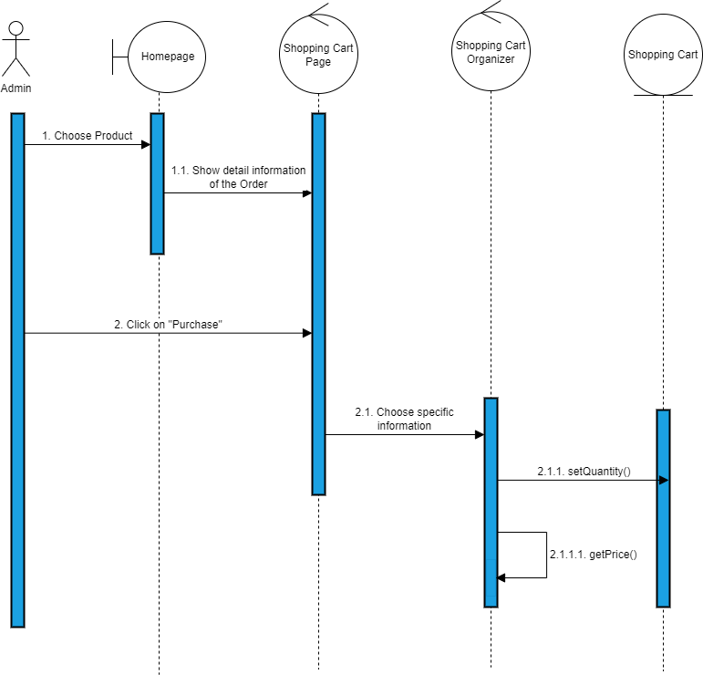

2.1.2. Delete Product

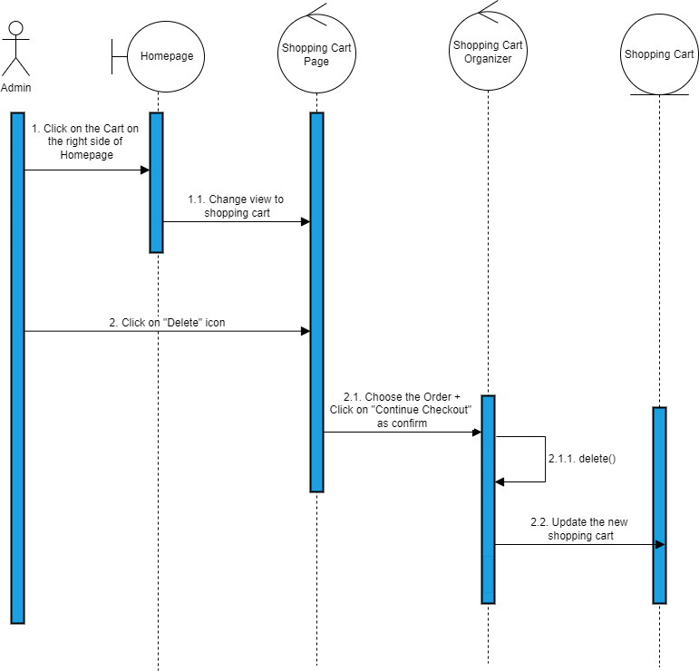

Class Diagram
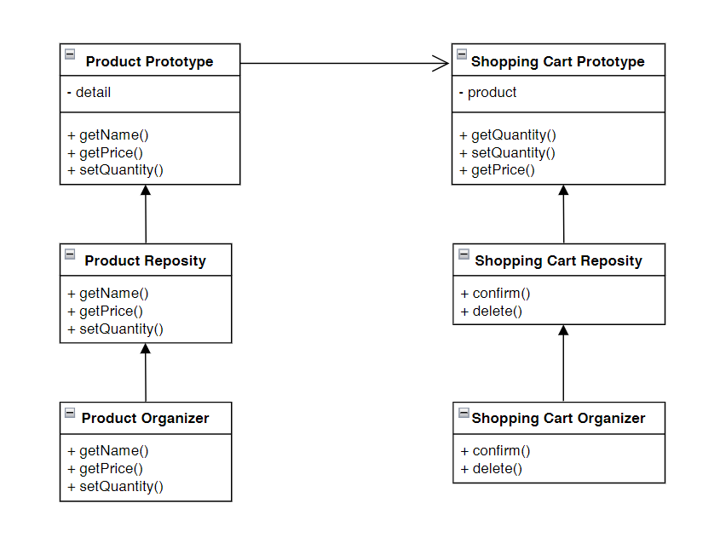

Derived Requirements
None.

